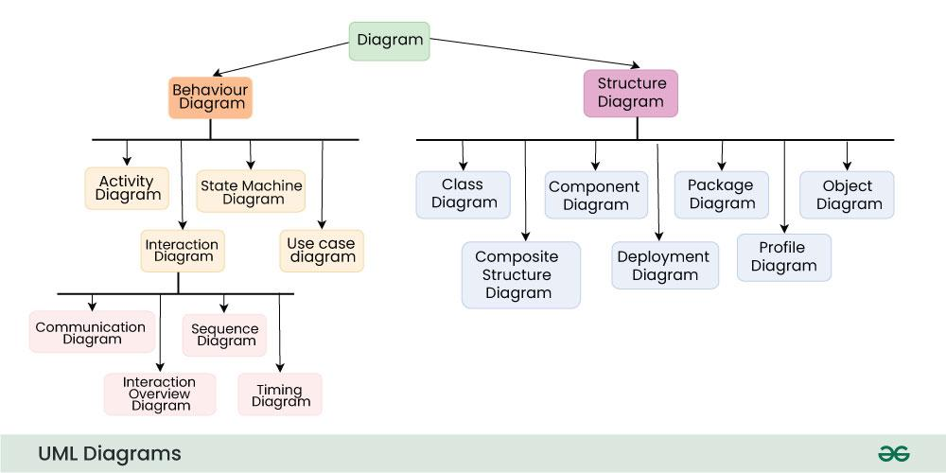

Sequence Diagrams - Unified Modeling Language (UML)
A Sequence Diagram is a key component of Unified Modeling Language (UML) used to visualize the interaction between objects in a sequential order. It focuses on how objects communicate with each other over time, making it an essential tool for modeling dynamic behavior in a system. Sequence diagrams illustrate object interactions, message flows, and the sequence of operations, making them valuable for understanding use cases, designing system architecture, and documenting complex processes.
What are Sequence Diagrams?
Sequence diagrams are a type of UML (Unified Modeling Language) diagram that visually represent the interactions between objects or components in a system over time. They focus on the order and timing of messages or events exchanged between different system elements. The diagram captures how objects communicate with each other through a series of messages, providing a clear view of the sequence of operations or processes.
Why use Sequence Diagrams?
Sequence diagrams are used because they offer a clear and detailed visualization of the interactions between objects or components in a system, focusing on the order and timing of these interactions. Here are some key reasons for using sequence diagrams:
- Visualizing Dynamic Behavior: Sequence diagrams depict how objects or systems interact with each other in a sequential manner, making it easier to understand dynamic processes and workflows.
- Clear Communication: They provide an intuitive way to convey system behavior, helping teams understand complex interactions without diving into code.
- Use Case Analysis: Sequence diagrams are useful for analyzing and representing use cases, making it clear how specific processes are executed within a system.
- Designing System Architecture: They assist in defining how various components or services in a system communicate, which is essential for designing complex, distributed systems or service-oriented architectures.
- Documenting System Behavior: Sequence diagrams provide an effective way to document how different parts of a system work together, which can be useful for both developers and maintenance teams.
- Debugging and Troubleshooting: By modeling the sequence of interactions, they help identify potential bottlenecks, inefficiencies, or errors in system processes.
Sequence Diagram Notations
1. Actors
An actor in a UML diagram represents a type of role where it interacts with the system and its objects. It is important to note here that an actor is always outside the scope of the system we aim to model using the UML diagram.
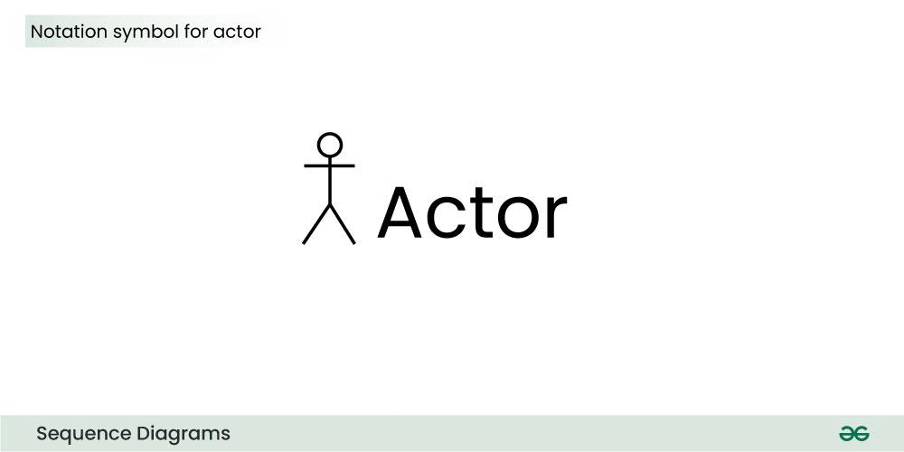
We use actors to depict various roles including human users and other external subjects. We represent an actor in a UML diagram using a stick person notation. We can have multiple actors in a sequence diagram.
For example:
Here the user in seat reservation system is shown as an actor where it exists outside the system and is not a part of the system.
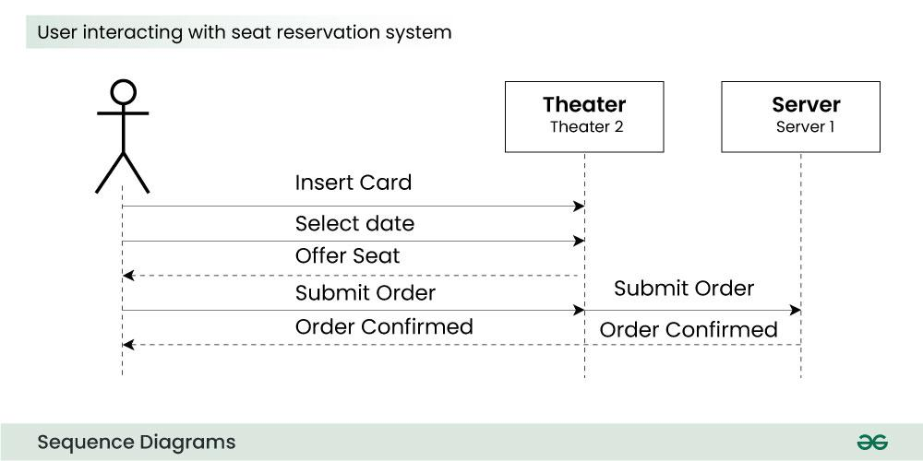
2. Lifelines
A lifeline is a named element which depicts an individual participant in a sequence diagram. So basically each instance in a sequence diagram is represented by a lifeline. Lifeline elements are located at the top in a sequence diagram. The standard in UML for naming a lifeline follows the following format:
Instance Name : Class Name
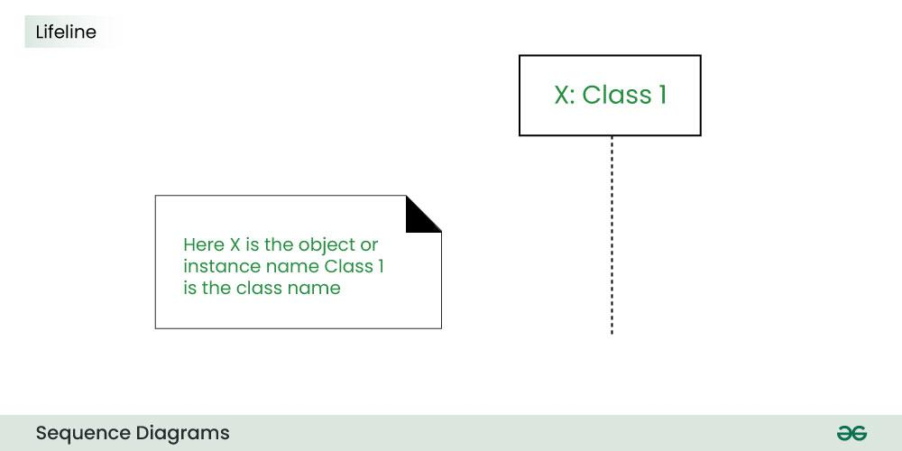
We display a lifeline in a rectangle called head with its name and type. The head is located on top of a vertical dashed line (referred to as the stem) as shown above.
- If we want to model an unnamed instance, we follow the same pattern except now the portion of lifeline's name is left blank.
- Difference between a lifeline and an actor
  - A lifeline always portrays an object internal to the system whereas actors are used to depict objects external to the system.
The following is an example of a sequence diagram:
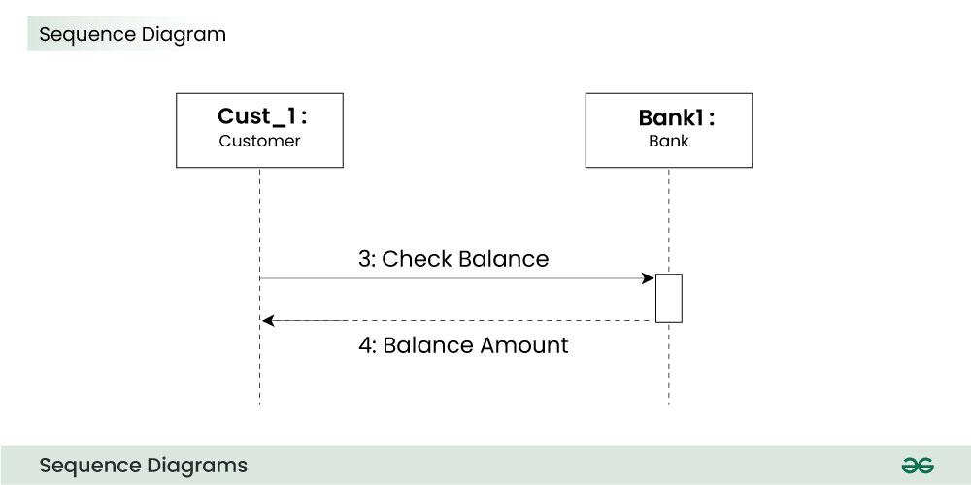
3. Messages
Communication between objects is depicted using messages. The messages appear in a sequential order on the lifeline.
- We represent messages using arrows.
- Lifelines and messages form the core of a sequence diagram.
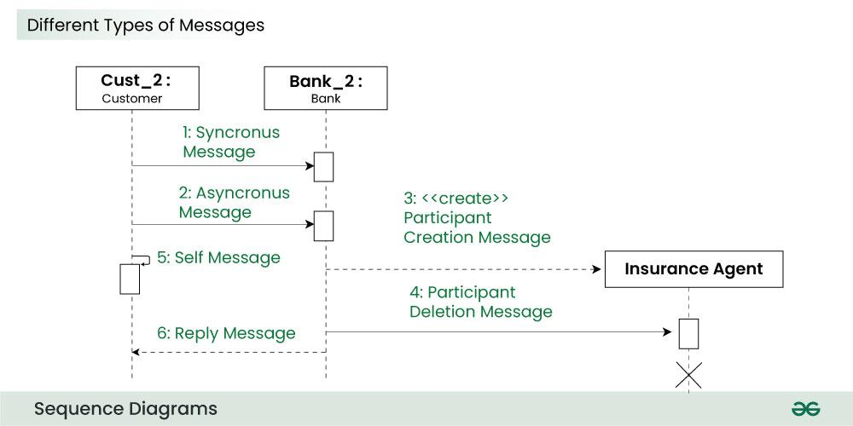
Messages can be broadly classified into the following categories:
1. Synchronous messages
A synchronous message waits for a reply before the interaction can move forward. The sender waits until the receiver has completed the processing of the message. The caller continues only when it knows that the receiver has processed the previous message i.e. it receives a reply message.
- A large number of calls in object oriented programming are synchronous.
- We use a solid arrow head to represent a synchronous message.
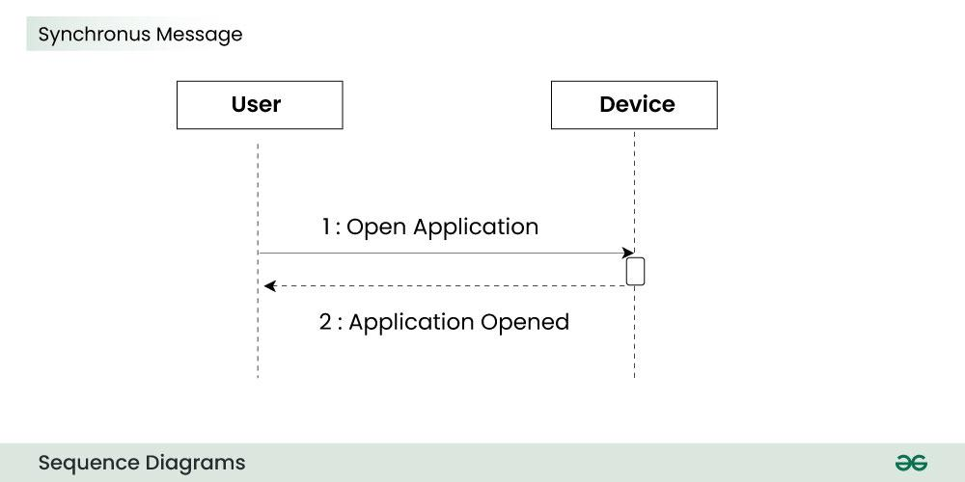
2. Asynchronous Messages
An asynchronous message does not wait for a reply from the receiver. The interaction moves forward irrespective of the receiver processing the previous message or not. We use a lined arrow head to represent an asynchronous message.
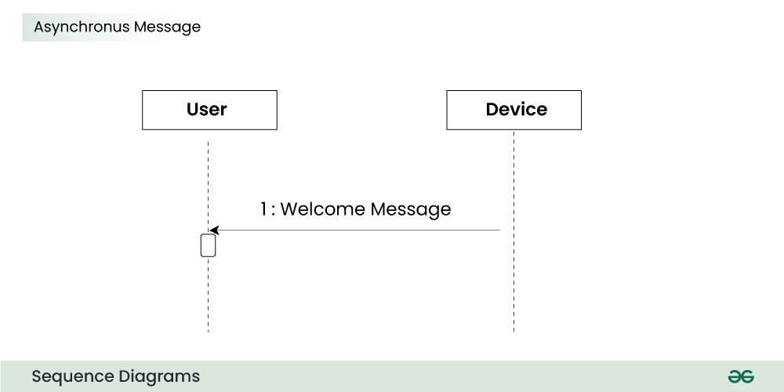
4. Create message
We use a Create message to instantiate a new object in the sequence diagram. There are situations when a particular message call requires the creation of an object. It is represented with a dotted arrow and create word labelled on it to specify that it is the create Message symbol.
For example:
The creation of a new order on a e-commerce website would require a new object of Order class to be created.
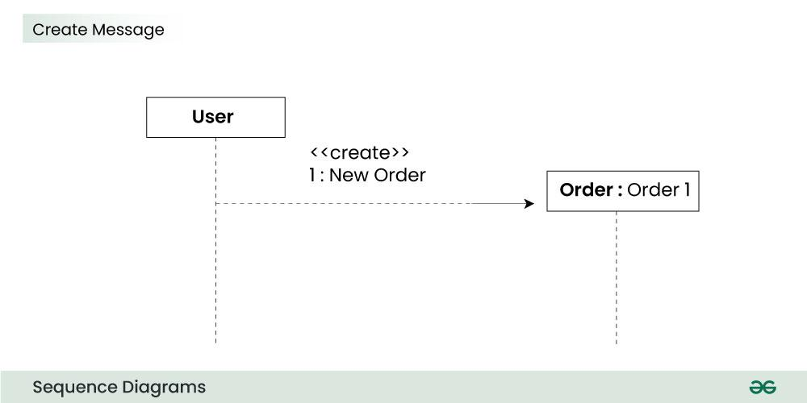
5. Delete Message
We use a Delete Message to delete an object. When an object is deallocated memory or is destroyed within the system we use the Delete Message symbol. It destroys the occurrence of the object in the system.It is represented by an arrow terminating with a x.
For example:
In the scenario below when the order is received by the user, the object of order class can be destroyed.
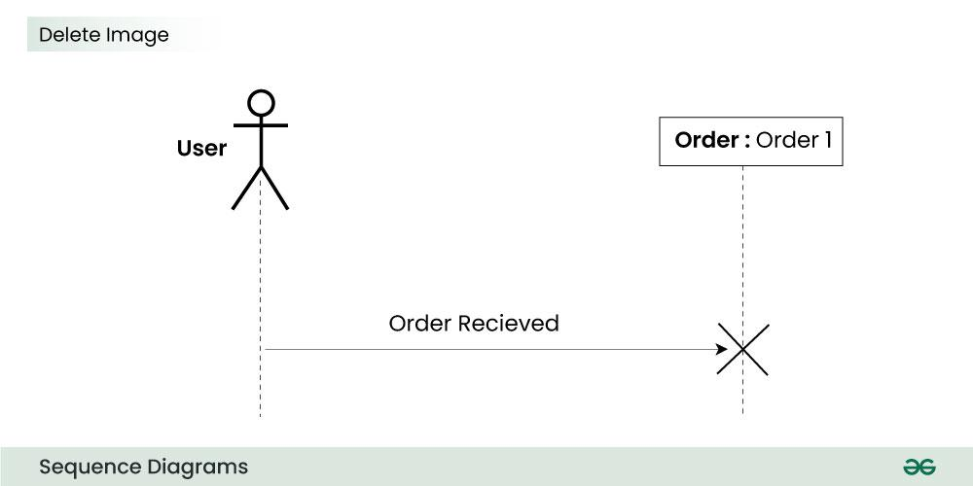
6. Self Message
Certain scenarios might arise where the object needs to send a message to itself. Such messages are called Self Messages and are represented with a U shaped arrow.
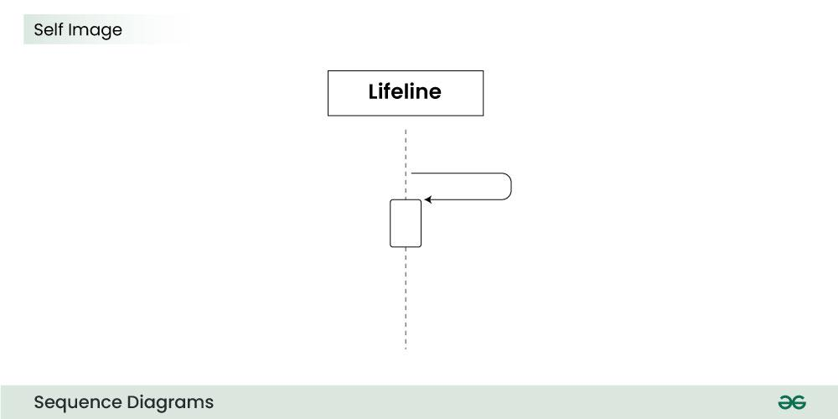
For example:
Consider a scenario where the device wants to access its webcam. Such a scenario is represented using a self message.
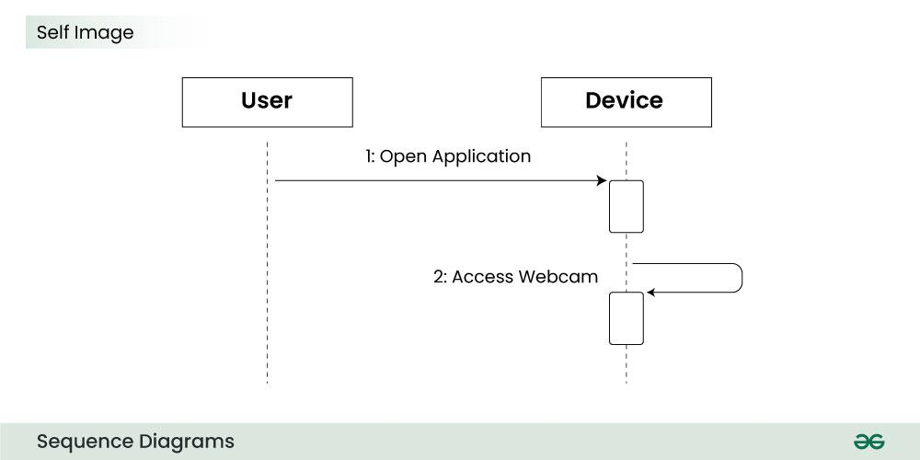
7. Reply Message
Reply messages are used to show the message being sent from the receiver to the sender. We represent a return/reply message using an open arrow head with a dotted line. The interaction moves forward only when a reply message is sent by the receiver.
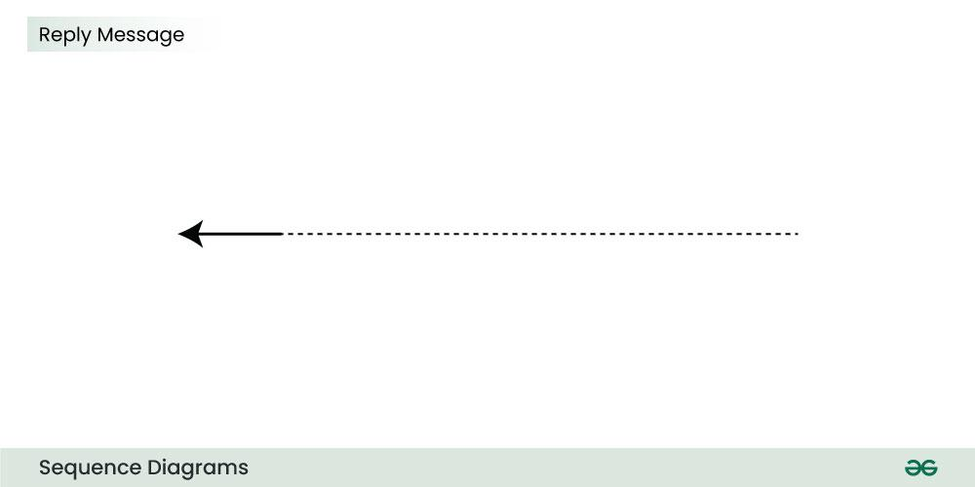
For example:
Consider the scenario where the device requests a photo from the user. Here the message which shows the photo being sent is a reply message.
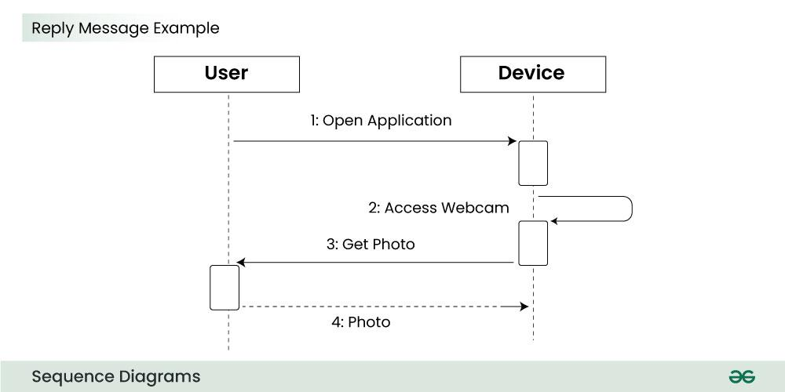
8. Found Message
A Found message is used to represent a scenario where an unknown source sends the message. It is represented using an arrow directed towards a lifeline from an end point.
For example:
Consider the scenario of a hardware failure.
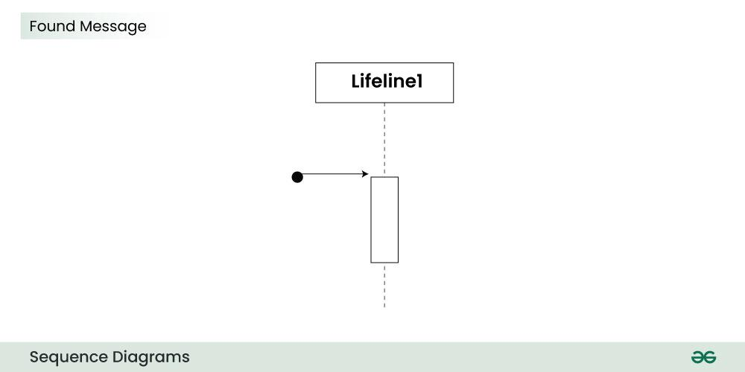
It can be due to multiple reasons and we are not certain as to what caused the hardware failure.
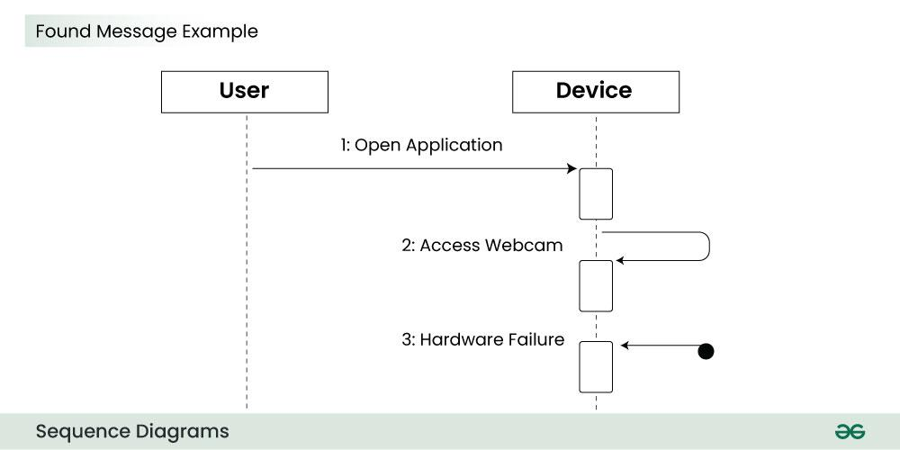
9. Lost Message
A Lost message is used to represent a scenario where the recipient is not known to the system. It is represented using an arrow directed towards an end point from a lifeline.
For example:
Consider a scenario where a warning is generated.
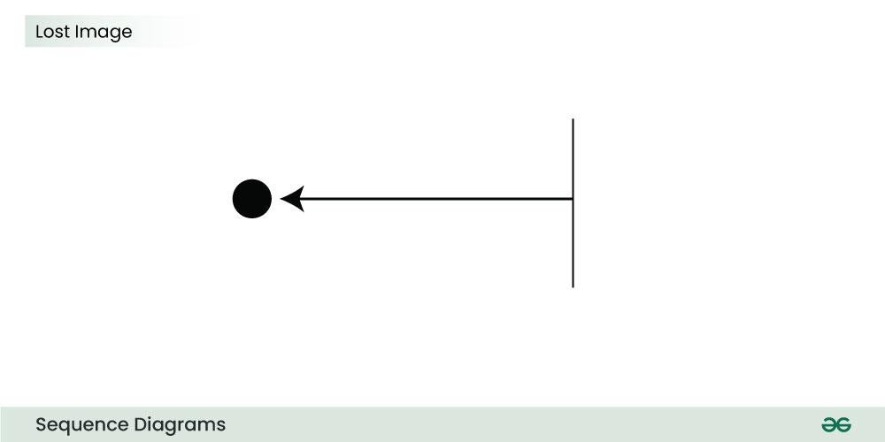
The warning might be generated for the user or other software/object that the lifeline is interacting with. Since the destination is not known before hand, we use the Lost Message symbol.
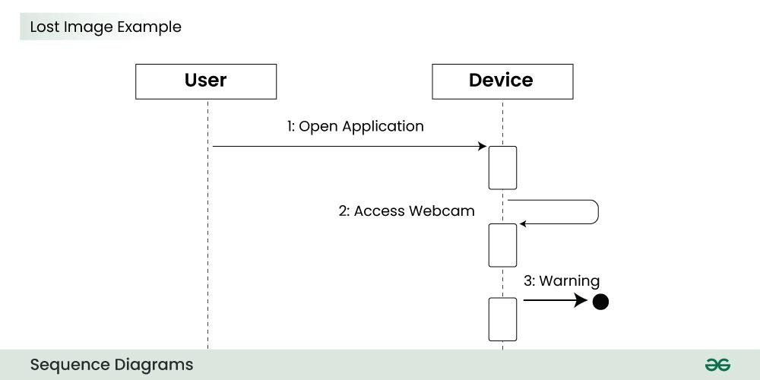
10. Guards
To model conditions we use guards in UML. They are used when we need to restrict the flow of messages on the pretext of a condition being met. Guards play an important role in letting software developers know the constraints attached to a system or a particular process.
For example:
In order to be able to withdraw cash, having a balance greater than zero is a condition that must be met as shown below.
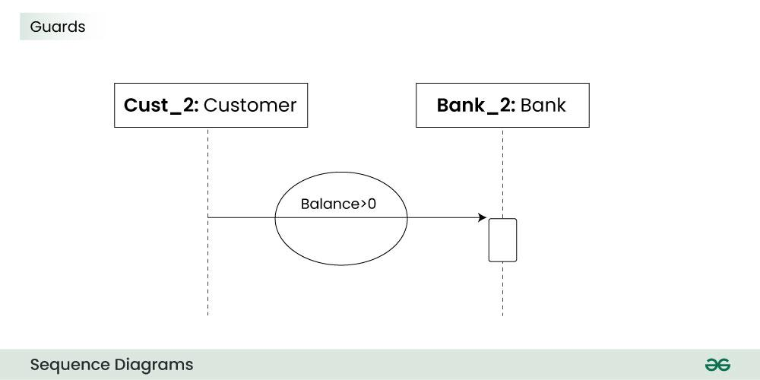
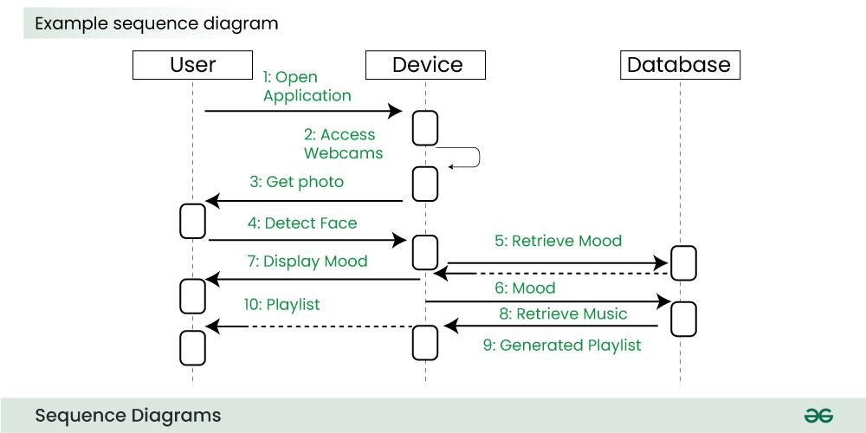
The above sequence diagram depicts the sequence diagram for an emotion based music player:
- Firstly the application is opened by the user.
- The device then gets access to the web cam.
- The webcam captures the image of the user.
- The device uses algorithms to detect the face and predict the mood.
- It then requests database for dictionary of possible moods.
- The mood is retrieved from the database.
- The mood is displayed to the user.
- The music is requested from the database.
- The playlist is generated and finally shown to the user.

Communication Diagram
A Communication Diagram (known as Collaboration Diagram in UML 1.x) is used to show sequenced messages exchanged between objects.
- A communication diagram focuses primarily on objects and their relationships.
- We can represent similar information using Sequence diagrams, however communication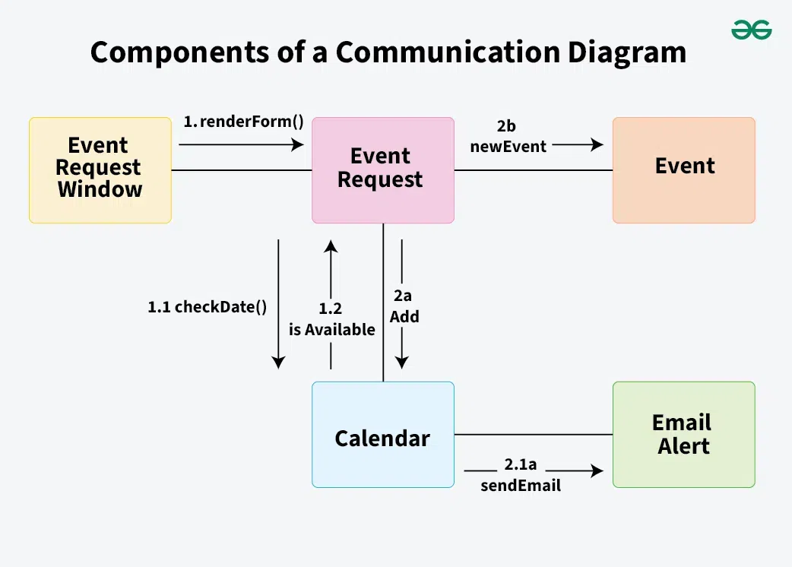 diagrams represent objects and links in a free form.
Timing Diagram
Timing Diagram are a special form of Sequence diagrams which are used to depict the behavior of objects over a time frame. We use them to show time and duration constraints which govern changes in states and behavior of objects.
Interaction Overview Diagram
An Interaction Overview Diagram (IOD) is a type of UML (Unified Modeling Language) diagram that illustrates the flow of interactions between various elements in a system or process. It provides a high-level overview of how interactions occur, including the sequence of actions, decisions, and interactions between different components or objects.
Notations for Interaction Overview Diagram
Annotations and explanations from the Interaction Overview UML diagrams feature several fundamental components that help to show control flow and system interactions. Here's a detailed explanation of these notations:
1. Initial Node
Represents the starting point of the interaction. It is shown as a small solid circle with a single outgoing control flow arrow.

2. Interaction Use
An Interaction Use is used to represent a reference to another interaction or sequence of interactions defined in another diagram or part of the system.An Interaction Use is represented by a rectangular box . Inside the box, you can include a label that specifies the name or reference of the interaction being used.
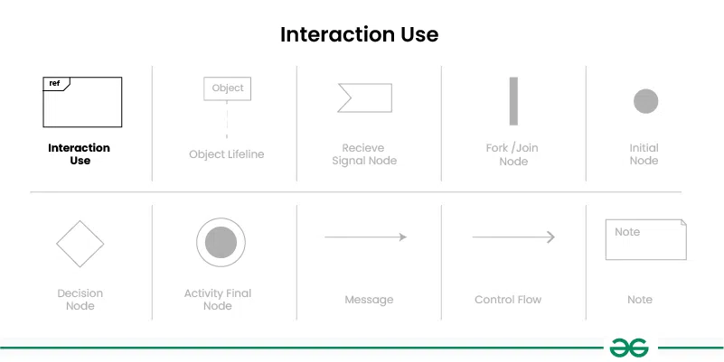
3. Interaction Fragment
Interaction fragments are used to group and organize interactions within the diagram.
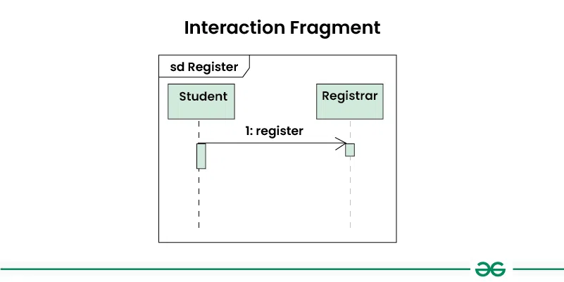
4. Object Lifeline
Represents the lifespan of an object during the interaction. It is a vertical dashed line that extends from the top of the diagram to the bottom, with the object's name or class at the top.
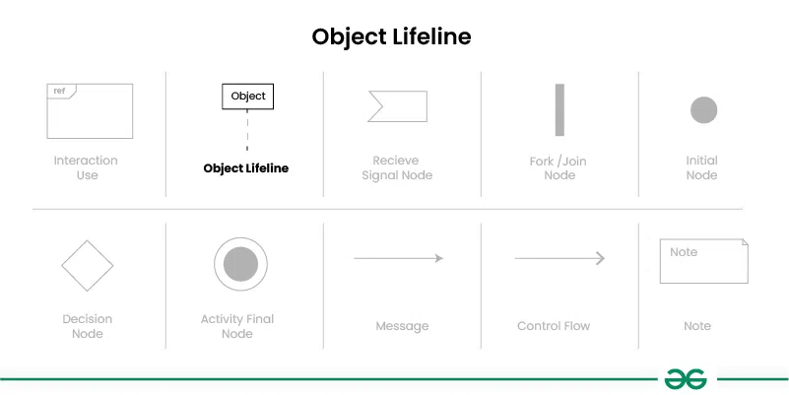
5. Message
Represents communication between objects or components in the system. Messages are shown as arrows between lifelines, indicating the direction of communication.

6. Control Flow
Represents the flow of control or sequence of actions in the interaction. It is shown as a solid arrow between elements in the diagram, indicating the order in which actions are performed.

7. Fork Node/Join Node
Represents a point in the interaction where multiple parallel actions can occur simultaneously. It is shown as a solid rectangle with multiple outgoing control flow arrows in case of Fork Node and ingoing control flow arrows in case of Join Node.
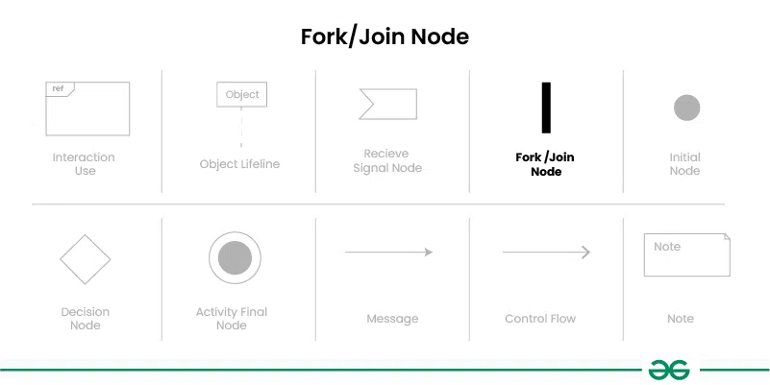
8. Decision Node
Represents a point in the interaction where a decision is made based on a condition. It is shown as a small diamond shape with incoming and outgoing control flow arrows representing different paths based on the decision.
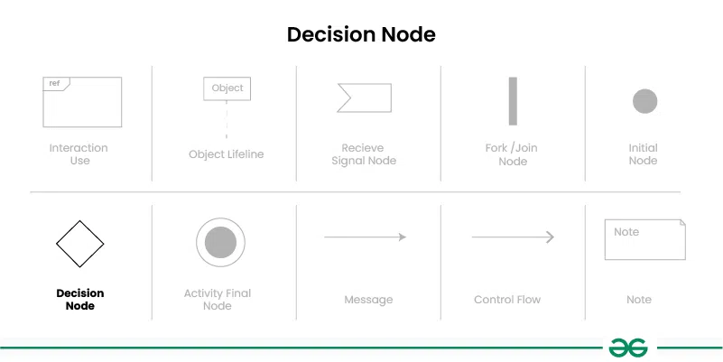
9. Receive Signal Node
Represents the receipt of a signal or event during the interaction. It is shown as a small rectangle with an incoming control flow arrow.
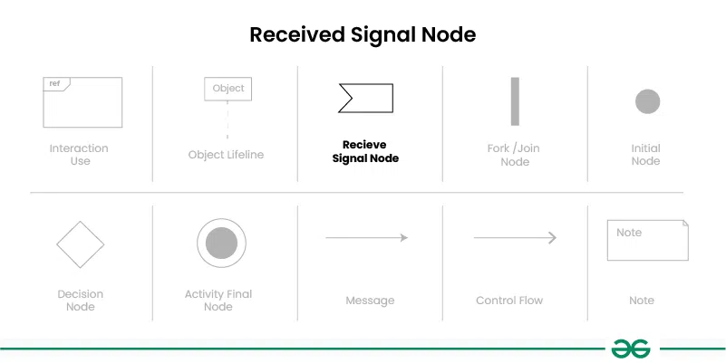
10. Final Node Represents the ending point of the interaction. It is shown as a small solid circle with no outgoing control flow arrows.

11. Note
Represents additional information or comments about the diagram. Notes are shown as a small rectangle with a label indicating the content of the note.

1. Student Admission Interaction Overview Diagram
Let's understand interaction overview diagram using Student Admission System :
The below example illustrates the admission process for a student who has been accepted into a university. Initially, the student is required to either accept or decline the admission offer. Upon acceptance, the student must proceed to register for classes and apply for housing. Once these steps are completed, the student is then required to make payment to the registrar. Failure to submit payment on time will result in the student being excluded by the registrar.
